Manuscript Maintenance System

Project Description

For

Manuscript Maintenance System

Introduction

We describe a data and information maintenance system for manuscript – named as Manuscript Maintenance System or (MMS for short).

The MMS will have one or more Librarians who will maintain all data regarding the manuscripts available in the library. There will also be one or more Users of the MMS who will perform various functions within the operation of the MMS itself.. The main owner of the system will be the Administrator. He/She will establish other Users in the MMS and give them Roles. These roles will be mapped to functions and operations that the User is allowed to perform on the MMS. The main role will be that of the Librarian.

System Overview
The following diagram shows the bird’s eye-view of the MMS
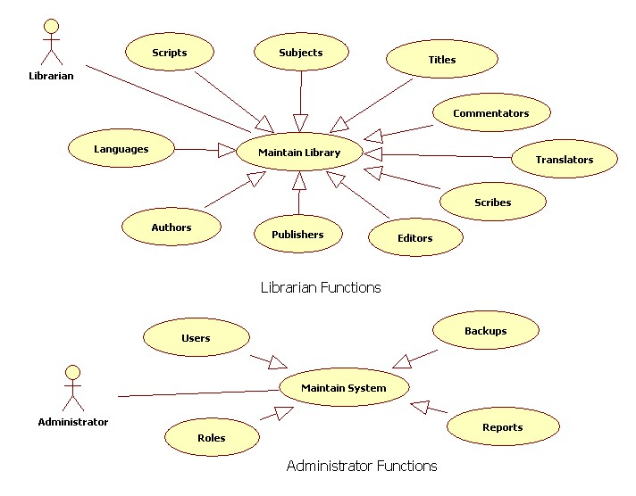

The Librarian maintains Things in the Manuscript Library. The library contains Titles. Titles have one or more Authors. They also have Subjects. They are in one or more Languages and Scripts. They are edited by one or more Editors, and have Commentaries by one or more Commentators. They are published by one or more Publishers. They are also written by one or more Scribes in one or more Scripts. Each Commentary can have one or more Revisions by Editors.

The Administrator establishes Users & UserRoles. He or she then allows the users to access and operate the MMS.

System Details
Things in the system are composite entities with fields as depicted below.
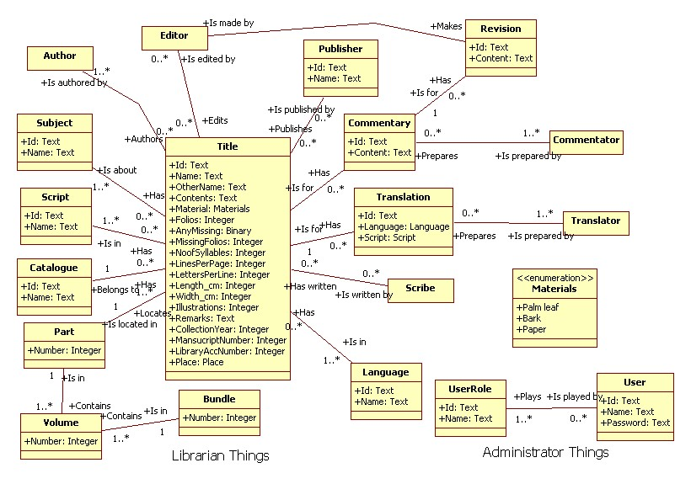
- A Title is a manuscript title by which a manuscript item will be known
- A Subject is a topic of knowledge by which Titles are classified
- The Title will have one or more Authors.
- Editors edit the descriptions of Titles.
- Publishers publish zero or more Titles.
- Zero or more Commentaries can be made on Titles.
- Commentators make Commentaries.
- Translators translate Title contents i.e. contents of the manuscript.
- Titles are in particular Scripts, like Brahmi, Grantha etc.
- Titles are in particular languages, like Sanskrit, Prakrit, Pali, Malayalam etc
- Titles are recorded by Scribes, like BaaNa, Brathrhari, KaaLidaasa etc
- Catalogues contain Titles.
- Titles are stored in Parts.
- Parts are in Volumes.
- Volumes are in Bundles.
- All persons existing in the system will have Roles. They can be Translators, Editors, Publishers etc. They can also be Scribes! Both living and dead persons can exist in the system.
- UserRoles are established by the Administrator for allowing and restriction of access to parts of the system. These are not Roles like Scribe, Editor, Author etc.

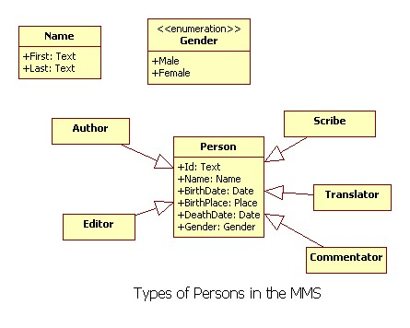
Persons can be Authors, Editors, Scribes, Translators and Commentators. They are identified by an abbreviation and have the attributes depicted above. A person without a value for death date is by definition, alive (!). Death dates are mainly attributes of Scribes, who are historical persons.

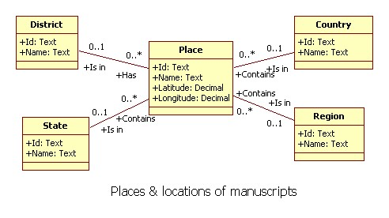
Places are the locations where a manuscript was sourced or is located. A place is identified by an abbreviation and has a name. It may b located in a region, country, state, district etc. MMS will not have a hierarchy of region/country/state/district. These are just attributes that may or may not be given to a place.

Possible DB design
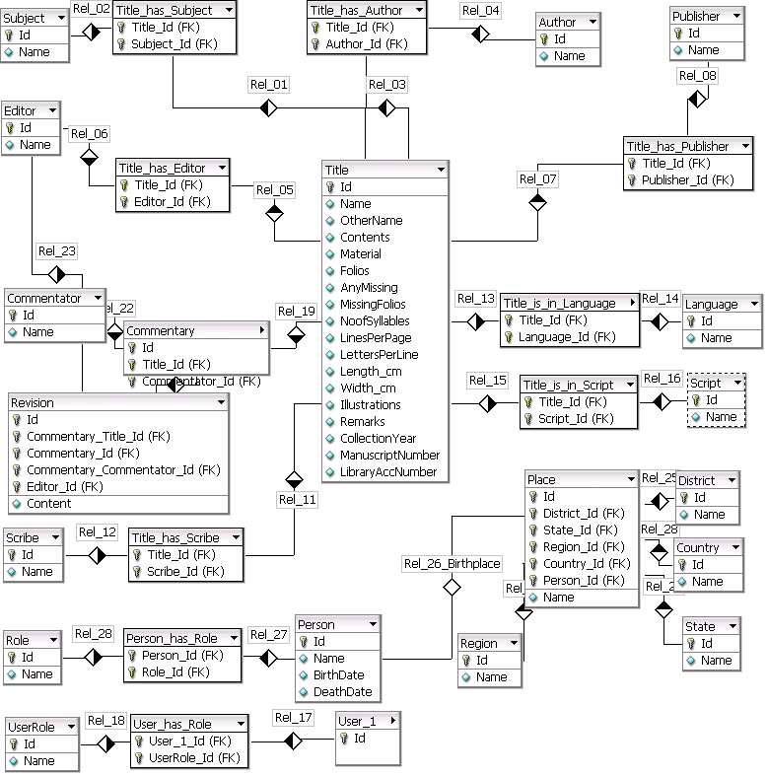

A possible database design is depicted above, with entities and relations as normally understood in database terminology. 1:1, 1:M and M:N relations are part of this design. This can of course be revised and enhanced after reviews and discussions.

Platform details and Architectural requirements
The system will be built using the .Net platform and MS Windows (Win32). It will use MS Access initially, and later migrate to a multi-user DBMS like MS SQL Server, MySQL etc. The design will be independent of the DBMS and will have a UI layer, a Business Logic layer and a Data storage/Data base layer. These layers will be designed and presented for review to vendor project manager or peers.

Agreement Terms
The fully tested source code will be delivered along with shrink-wrapped package for installation and acceptance testing by Samskrthi. Acceptance Test Cases and plans will be documented and approved by Samskrthi. Acceptance Test Reports should satisfy the planned test cases and be reviewed/approved by the vendor project manager and Samskrthi. All other documentation artifacts, like Detailed Specification, Design artifacts and Test Suites will also be delivered to Samskrthi.

Conclusion and state of the system specification
This is a draft of the specifications for the MMS. This specification will undergo iterative revisions and details will be added. The methodology of work needs to be brainstormed and decided, so that plans, resources, terms and start/end dates can be prepared. This will be a communication between Samskrthi Foundation and the Development/Build team or vendor. A Statement of Work (SOW) with scope delimitation, inclusions and exclusions, work methodology, team composition and roles, work-breakdown structures, effort and calendar time estimates are normally used to structure the communication and review.

